Git and GitHub

How to setup git for directory.

Note :-

1. We note use any space in the file name, you only use the “_”,”camel case<just like ‘MyNameIsDan’>”.
2. If you can use the space, so you use backslash “\” just like <my\ name\ is\ dan>.

----------------------------------------------------------------------------------------------------------------

1. we can download the git in Linux.

Point:-

(1) open the Terminal to use the shortcut key(ctrl + alt = t).

(2) then you written the commant.

$ sudo apt-get install git

$ <password>

(3)then you see that git install in your computer.

----------------------------------------------------------------------------------------------------------------

1. how to check Git.

Point:-

1. open the Terminal and written the commant.

$ git

-----------------------------------------------------------------------------------------------------------------------------------

1. when you use git first time, so git need your name and email id.

Point:-

1. Open the terminal and follow the commant.

$ git config --global user.name <enter the user name>

$ git config --gobal user.email<enter the user email id >

-----------------------------------------------------------------------------------------------------------------------------------

1. Go to the folder which you want to use git

$ git init => this will initialize git in that folder and “.git ” file will created

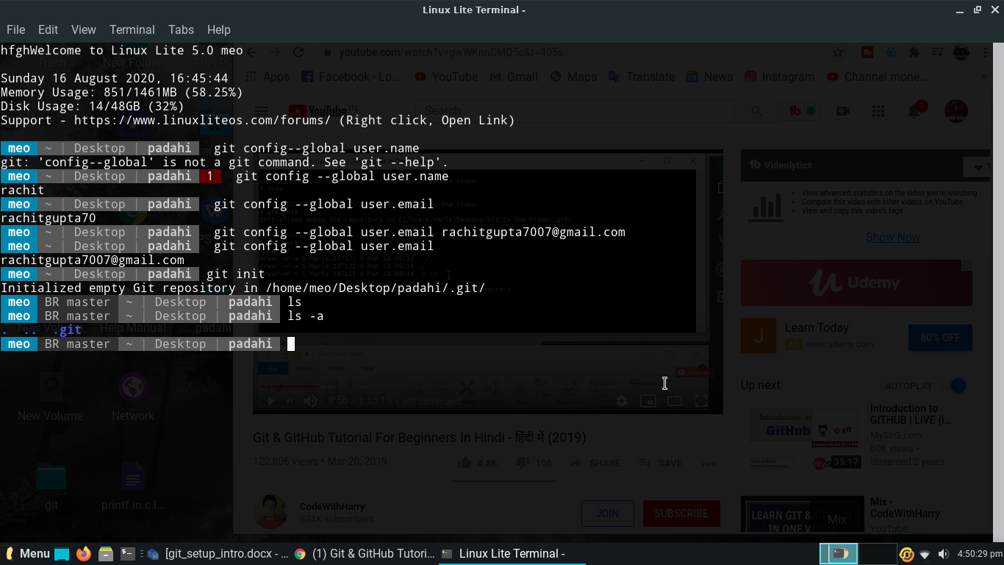

---------------------------------------------------------------------------------------------------------------

1. The structure of git .
2. Untracked is file position than git is do not mean the untracked. If you want to add your file then git started to save the file.
3. Staged is like a field those file is come under the commit. Commit is those position that git is record the file in your computer.
4. Unmodified
5. Modified

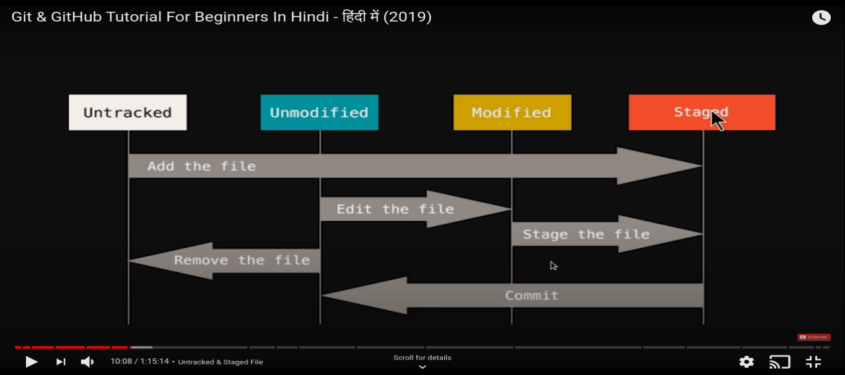

----------------------------------------------------------------------------------------------------------------

1. We can use git status to check the file”file is add or not” in the directory.

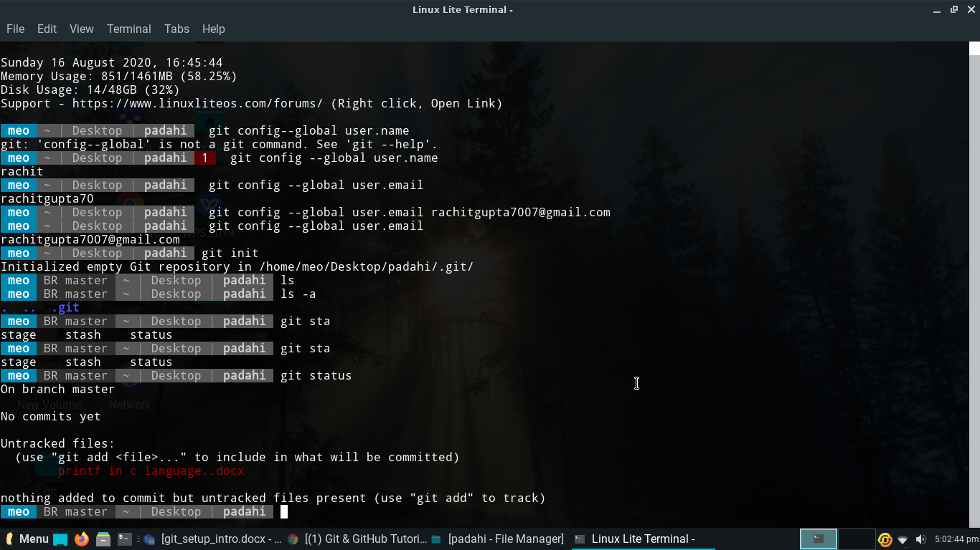

----------------------------------------------------------------------------------------------------------------

1. How to add file in git. When you add the file with use this commant.

$ git add <file name>

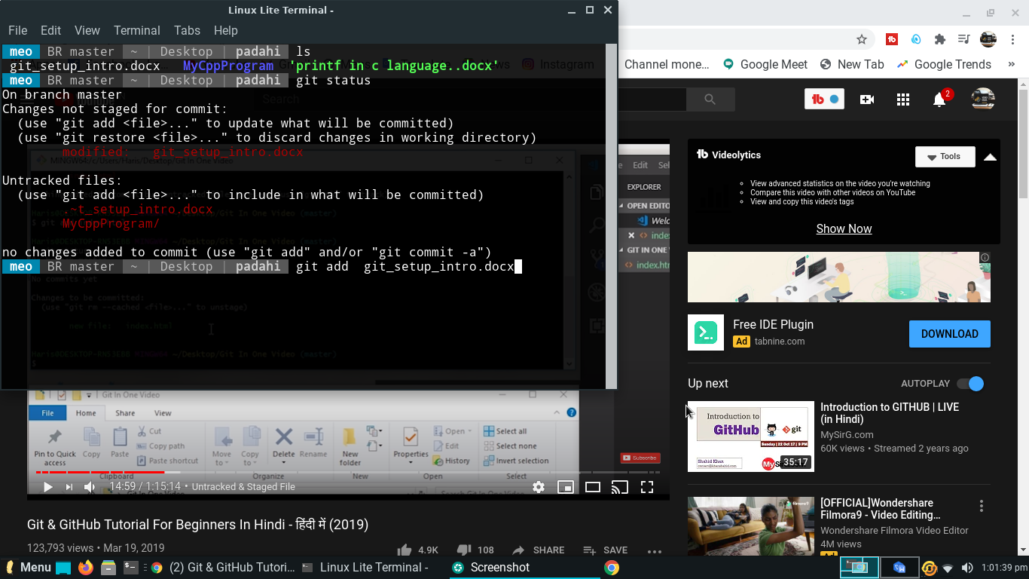

----------------------------------------------------------------------------------------------------------------

1. When you add file then we commit the file to git save record of file.

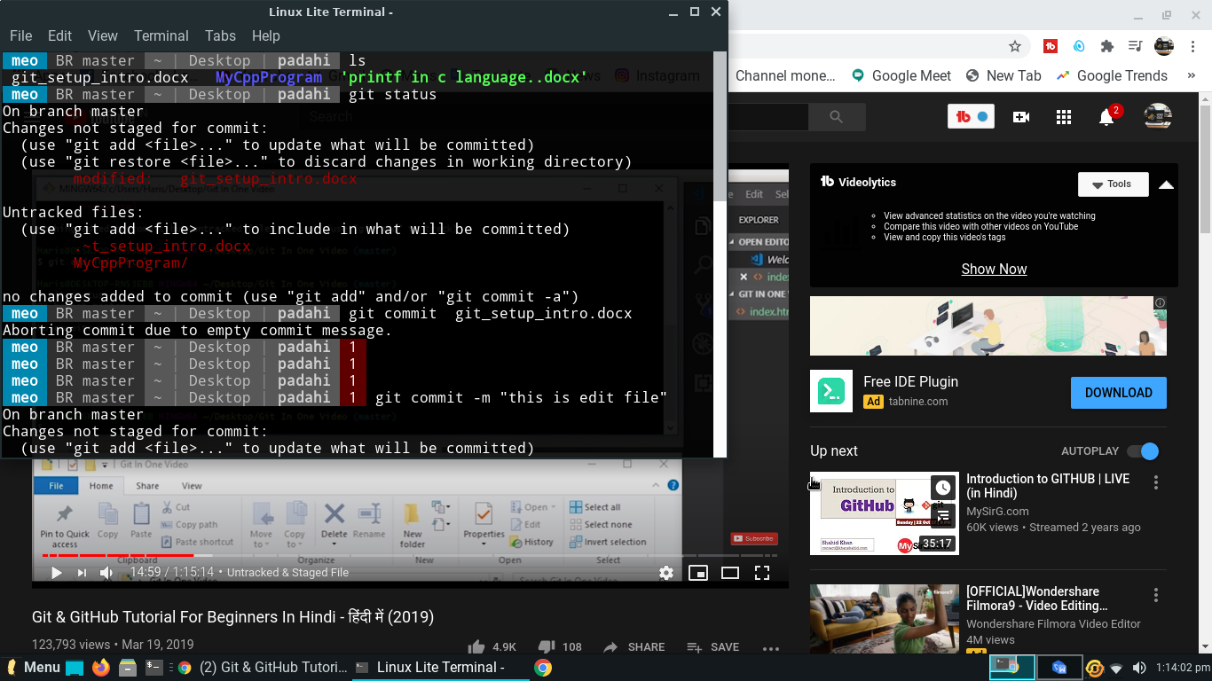

----------------------------------------------------------------------------------------------------------------

1. How to add and commit two or more file in git.

(1)When you have two or many file to add the file in git, so you use this commant.

$ git add -A

1. when you add the file and you want to commit the file, so you use this commant

$ git commit -a -m ”write a massage”

1. Then you check the file with using this commant and than you see your all file is commit.

$ git status

----------------------------------------------------------------------------------------------------------------

1. What is git checkout commant ?

:- git checkout commant is check the working directory match with last commit.

:- if your all file is rewrite by anybody and you want to restore the file, so you use this commant.

$ git checkout => for single file.

$git checkout -f => for all file.

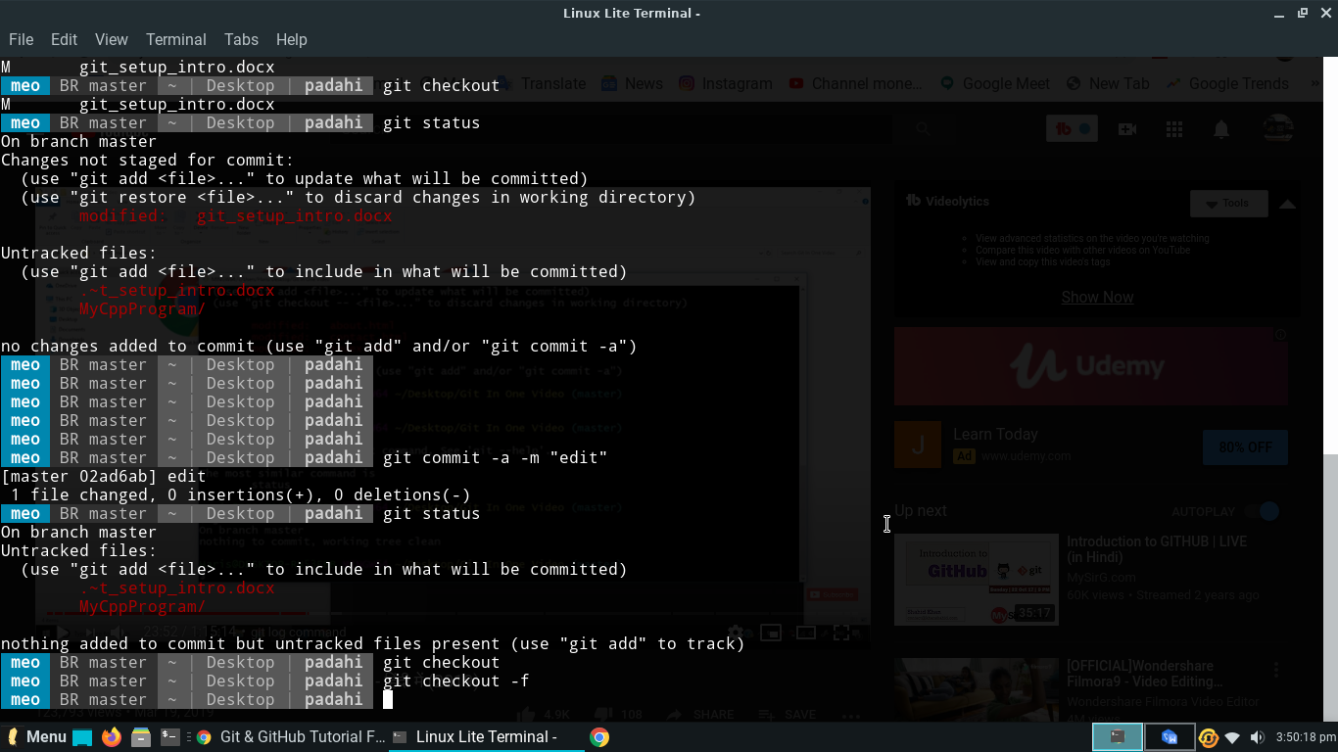

----------------------------------------------------------------------------------------------------------------

1. If want to show my all commit wen you are start using git, so using this commant.

$ git log

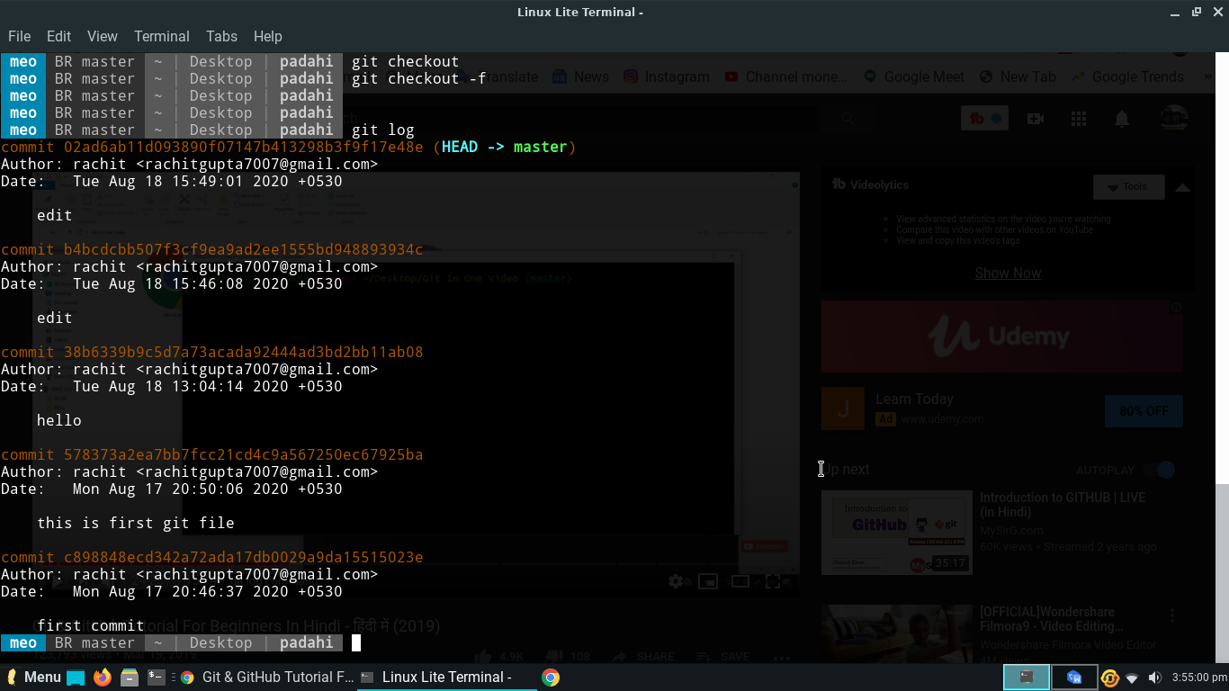

----------------------------------------------------------------------------------------------------------------

1. If want to show my any last commit and it changes, so use this commant.’

$ git log -p -<any last>

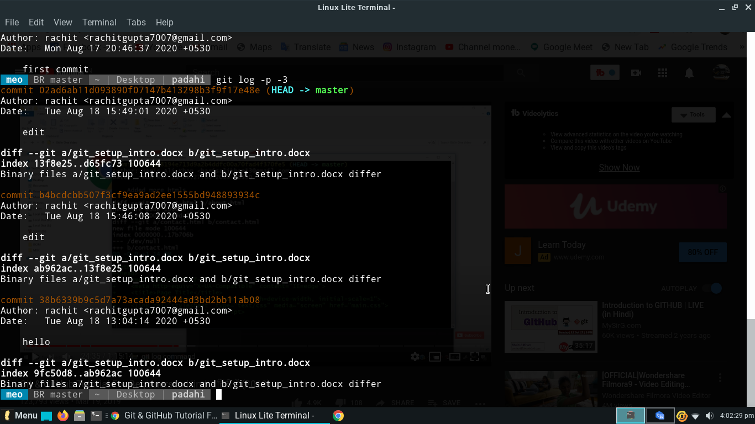

You see that your last 3 commit.

----------------------------------------------------------------------------------------------------------------

1. Git diff :-

----------------------------------------------------------------------------------------------------------------

1. How to remove the file in git and permanent remove in the disk.
2. Suppose We can make temporary files his name <Waste file.docx> and this file is add in git and also commit it.

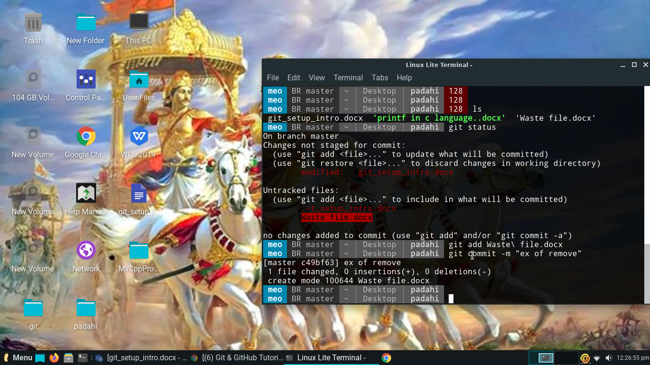

1. When we want to remove this file,so use this command

$ git rm --cached <file name> => this command is use when you want to remove file in git.

(1) 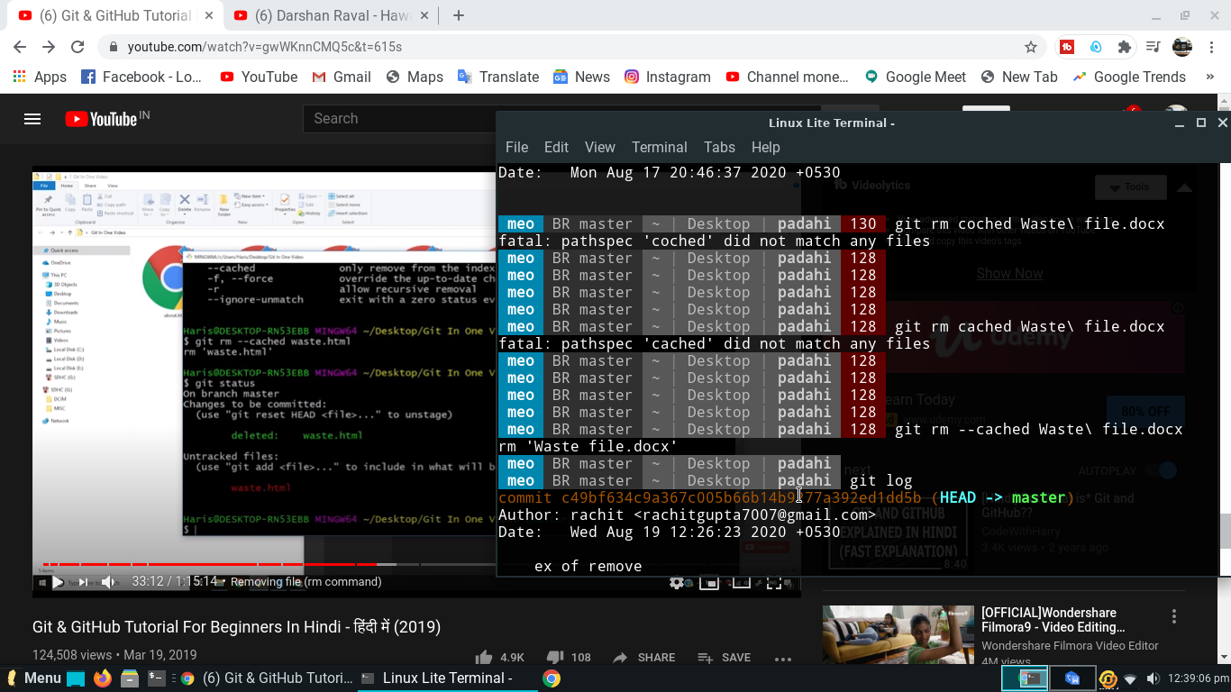

(2)

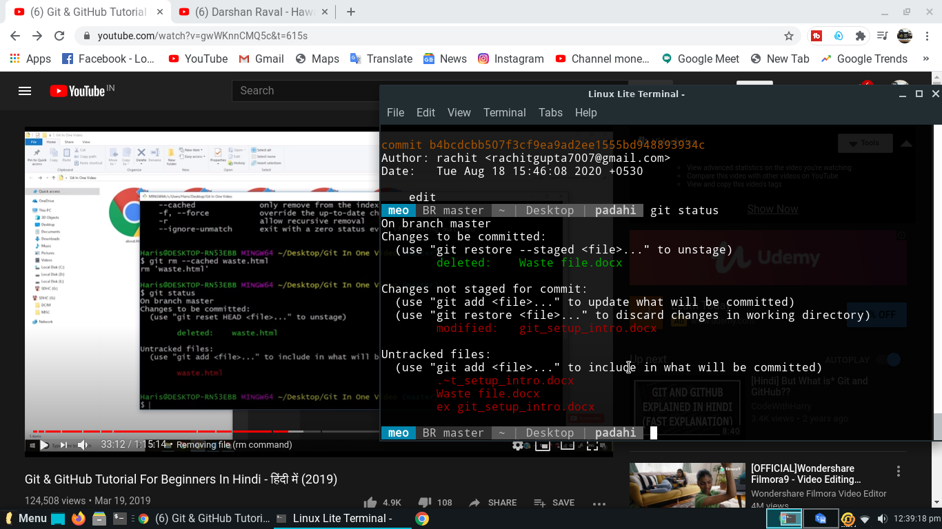

$ git rm <file name> =>when you want to remove file in both side.

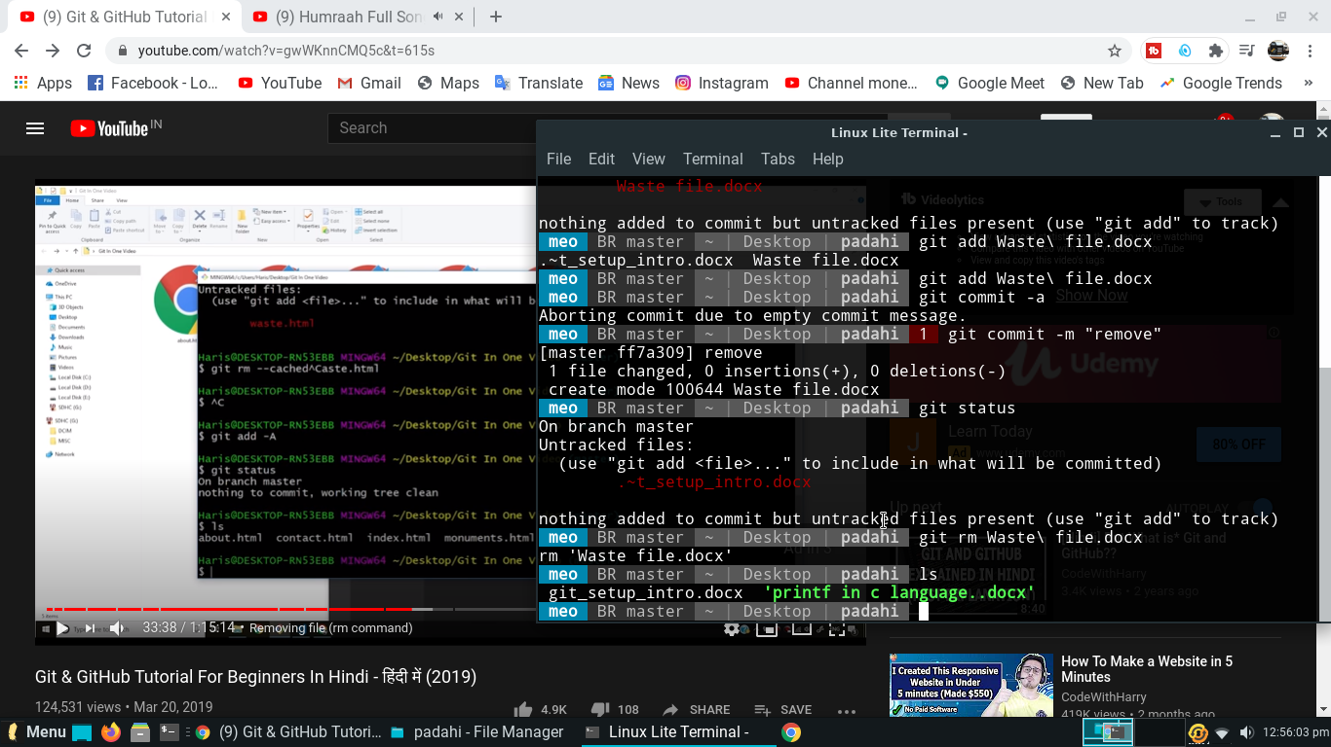

----------------------------------------------------------------------------------------------------------------

1. How to show git in short way with using there command.

$ git status -s => it show all working record and overview.

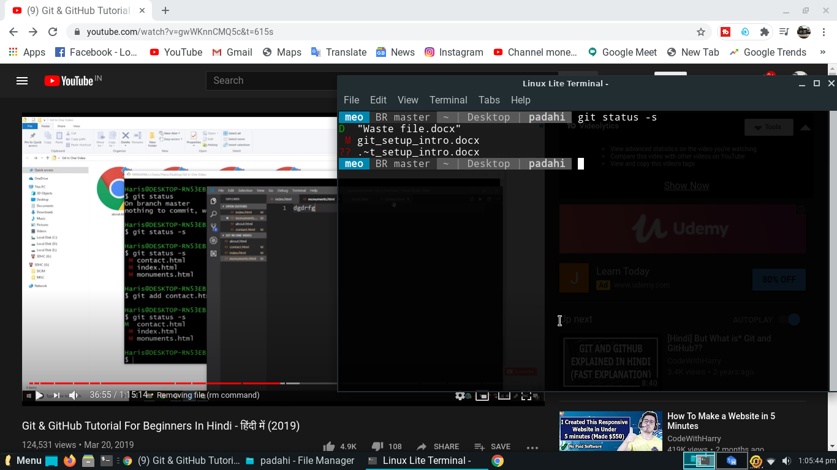

D= delete , M= modified , ??= working (file is open).

----------------------------------------------------------------------------------------------------------------

1. What is Branches in git and it work?

(1) we make unlimited branches in git. Branches is very cool and impotent function in git. The default branch name in git is master.

=> Suppose you have a website like ‘Facebook’ and your employee want developed the website so your employee use another branch and when his work is done and working successful. Then your employee want to merge the work in main branch.

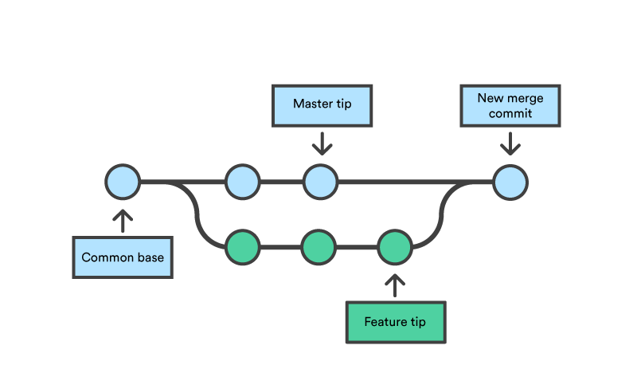

(2) we want to make and select the branch in git, so you can use these command.

$ git branch <branch name> => we want to make branch.

$ git checkout <branch name> => we want to select the branch.

=> what is the command to check branch.

$ git branch

1. If we want change the branch, so follow there command.

$ git checkout <branch name>

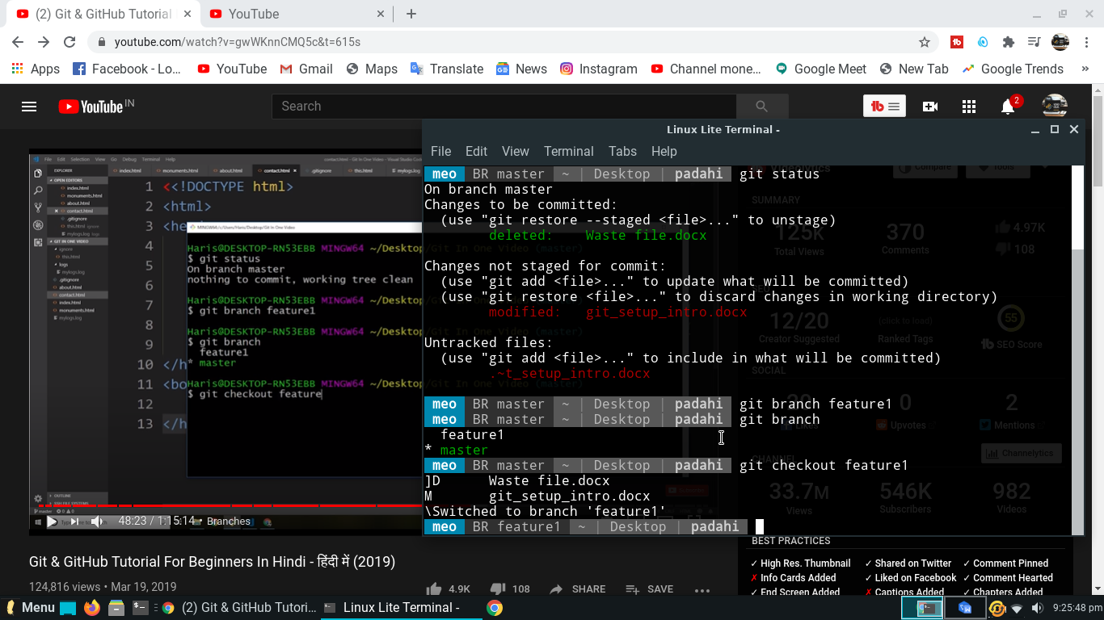

1. We make a document file <try.docx> and also do add and commit on the git in master branch because we want to do merge.

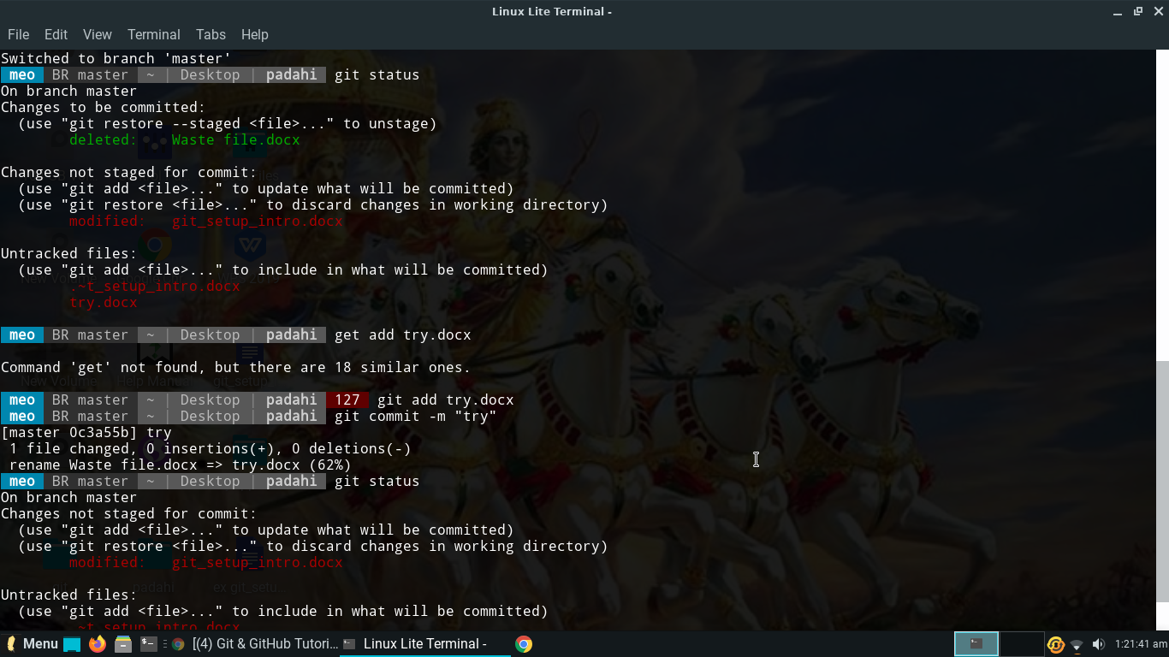

=> Then we shift the master branch to feature1 branch. then we edit the document file and redevelop the file.

=> when we want to merge the file, so you use there command.

$ git merge <branch name>

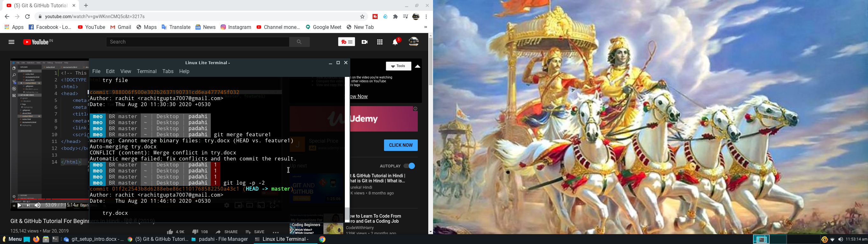

=> Suppose you want to make the branch and activate the branch in one command, so you can use there command.

$ git checkout -b <branch name>

----------------------------------------------------------------------------------------------------------------

1. What is GITHUB.

=> It is the online repository hub that our file is save permanent.

1. We can create the account in GITHUB website and add the first repository.
2. Then we copy the remote URL is give the website and then past the URL in terminal.

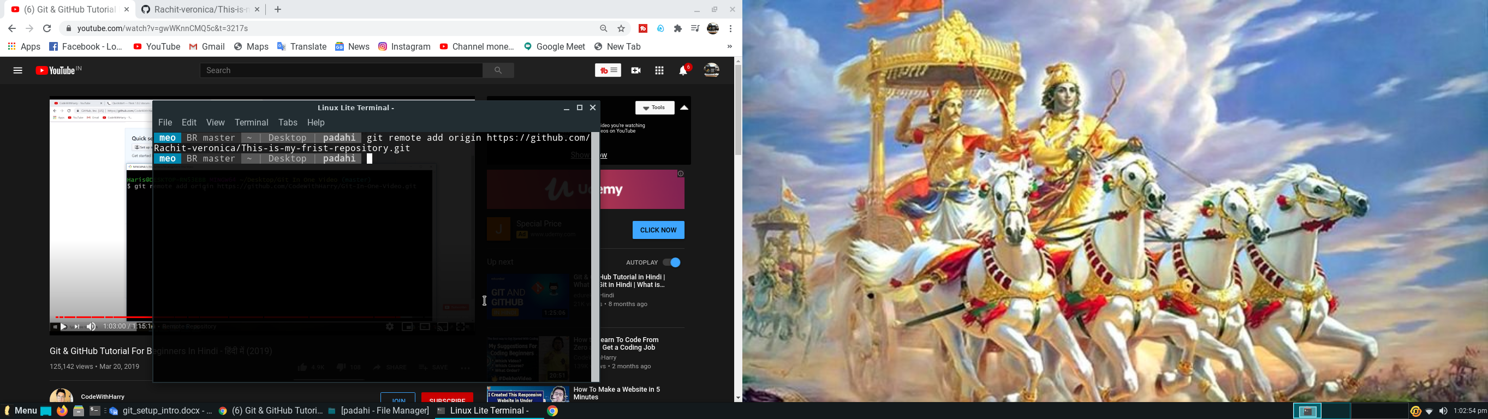

1. How to check remote with there command.

$ git remote

$ git remote -v => To show both URL.(push , fetch).

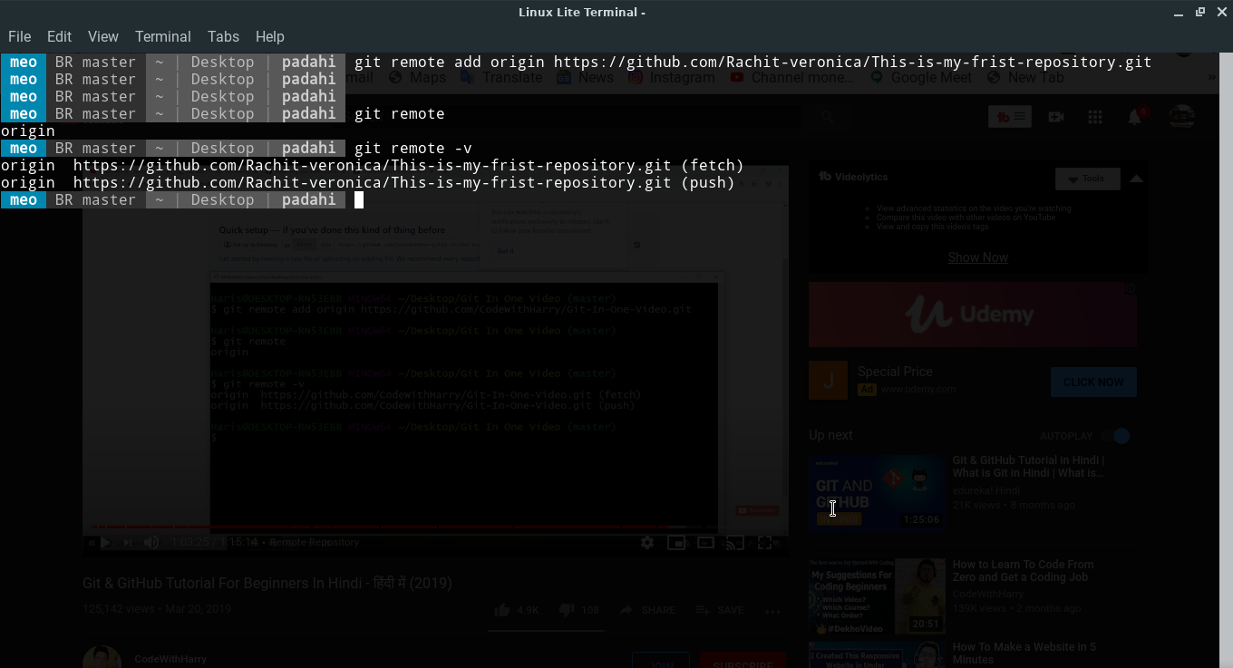

1. How to push the file you git ?

$ git push origin <file name or branch name>

1. If you want to do clone file, so you copy the link of file in git then you using there command.

$ git clone <file URL>

----------------------------------------------------------------------------------------------------------------

# Thank you